|  |
| --- |
| **M.Sc. (Chemistry) B.Ed.**  **CTET, PSTET, HPTET qualified**  **thakurkumar82@gmail.com** |
| **Class:-XII (Sci.) Name of Student……………………**  **Subject:- Chemistry**  **10 year QuStions**  **Chapter-12**  **Aldehydes, ketones & carboxylic acids** |

1. (a) Give IUPAC name of CH3 – CH = CH – CHO.

(b) How can you distinguish between ethanol and ethanal?

(c) How will you convert the following: (i) Toluene to benzoic acid?

(ii) Ethanol to propan-2-ol (iii) Propanal to 2-hydroxypropanoic acid

1. (a) Give IUPAC name of Salicylic acid.

(b) Chloroacetic acid is more acidic than acetic acid. Why?

(c) Write the products formed when (CH3)3C–CHO reacts with the following:

(i) Zinc amalgam and dilute hydrochloric acid

(ii) Concentrated sodium hydroxide solution (iii) Semicarbazide and a weak acid

1. (a) Carry out the following conversions : (i) P-nitrotoluene to 2-bromobenzoic acid (ii) Propanoic acid to acetic acid

(b) An alkene with molecular formula C5H10 on ozonolysis gives a mixture of two compounds, B and C. Compound B gives positive Fehling test and also reacts with iodine and NaOH solution. Compound C does not give Fehling solution test but forms iodoform. Identify the compounds A, B and C.

1. (a) Carry out the following conversions :

(i) Benzoic acid to aniline (ii) Bromomethane to ethanol.

1. 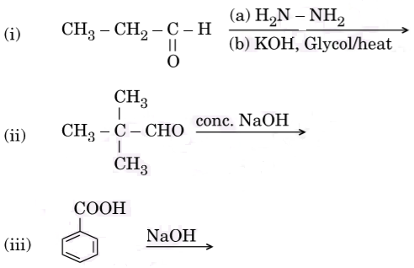Write the structure of major product(s) in the following :
2. Write the IUPAC name of the following compound :

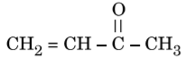

1. What happens when (a) Salicylic acid is treated with (CH3CO) 2O/H+?

(b) Phenol is oxidized with Na2Cr2O7/H+?

(c) Anisole is treated with CH3C*l*/anhydrous A*l*C*l*3? Write chemical equation in support of your answer.

1. (a) Predict the main product of the following reactions :

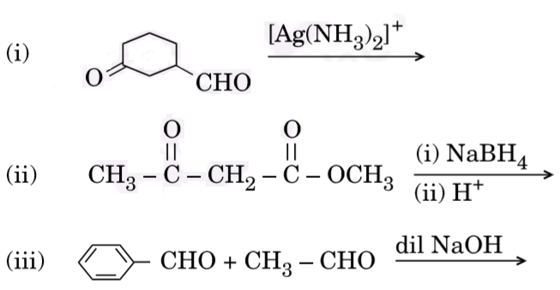

(b) Give a simple chemical test to distinguish between

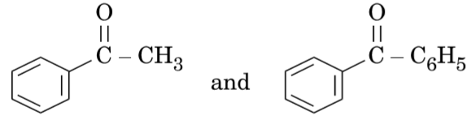

(c) Why is alpha (α) hydrogen of carbonyl compounds acidic in nature ?

1. (a) Write the main product formed when propanal reacts with the following reagents : (i) 2 moles of CH3OH in presence of dry HCl (ii) Dilute NaOH (iii) H2N – NH2 followed by heating with KOH in ethylene glycol.

(b) Arrange the following compounds in increasing order of their property as indicated:

(i) F – CH2COOH, O2N – CH2COOH, CH3COOH, HCOOH — acid character

(ii) Acetone, Acetaldehyde, Benzaldehyde, Acetophenone — reactivity towards addition of HCN

1. (a) Give reasons: (i) Benzoic acid is a stronger acid than acetic acid.

(ii) Methanal is more reactive towards nucleophilic addition reaction than ethanal.

(b) Give a simple chemical test to distinguish between propanal and propanone.

1. Complete the following reactions :

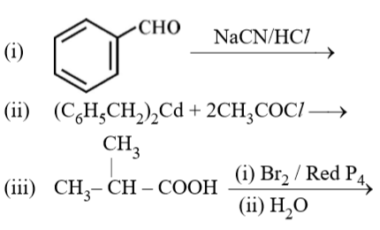

1. Write chemical equations for the following reactions:

(i) Propanone is treated with dilute Ba(OH)2.

(ii) Acetophenone is treated with Zn(Hg)/Conc. HCl

(iii) Benzoyl chloride is hydrogenated in presence of Pd/BaSO4.

1. (i) Give reasons: (a) HCHO is more reactive than CH3-CHO towards addition of HCN. (b) pKa of O2N–CH2–COOH is lower than that of CH3–COOH.

(c) Alpha hydrogen of aldehydes & ketones is acidic in nature.

(ii) Give simple chemical tests to distinguish between the following pairs of compounds: (a) Ethanal and Propanal (b) Pentan-2-one and Pentan-3-one.

1. (i) Write structure of the product(s) formed :

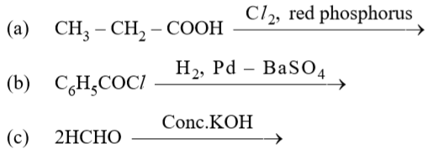

(ii) How will you bring the following conversions in not more than two steps?

(a) Propanone to propene (b) Benzyl chloride to phenyl ethanoic acid.

(c) Propene to Acetone (d) Propanoic acid to 2-hydroxypropanoic acid

(e) Benzoic acid to benzaldehyde (f) Ethyl benzene to Benzoic acid

(g) Toluene to benzaldehyde (h) ethanoyl chloride to ethanal

(iii)Write the reaction involved in the following:

(a) Etard reaction (b) Wolff-Kishner reduction

1. Give reasons :

(a) Propanone is less reactive than ethanal towards nucleophilic addition reactions. (b) O2N – CH2 – COOH has lower pKa value than CH3COOH.

(c) (CH3)2CH – CHO undergoes aldol condensation whereas (CH3)3C – CHO does not.

1. 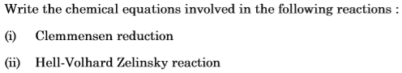

1. 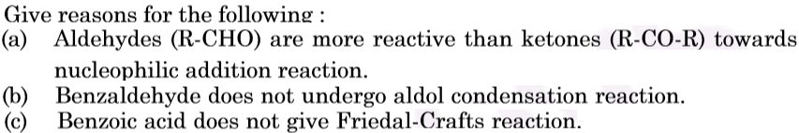

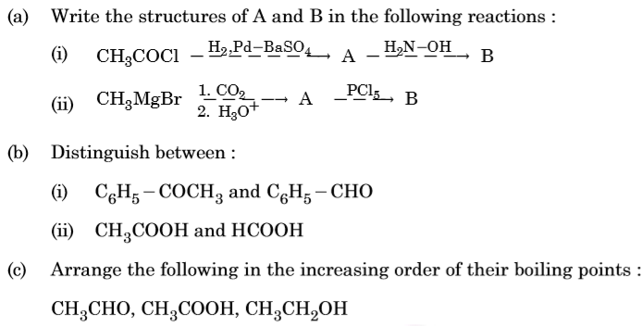

1. (a) Write the chemical equation for the reaction involved in Cannizzaro reaction.

(b) Draw the structure of the semicarbazone of ethanal.

(c) Why pKa of F-CH2-COOH is lower than that of C*l* – CH2 – COOH?

(d) Write the product in the following reaction:

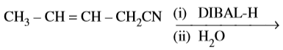

(e) How can you distinguish between propanal and propanone ?

1. How would you obtain the following : (i) Benzo quinone from phenol (ii) 2-Methylpropan-2-ol from methyl magnesium bromide (iii) Propan-2-ol from propene
2. 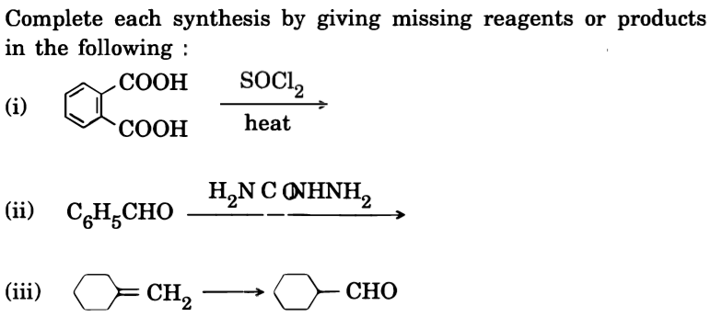
3. (a)Give chemical tests to distinguish between the following :

(i) Benzoic acid and ethyl benzoate (ii) Benzaldehyde and acetophenone

(b) How would you obtain the following :

(i) But-2-enal from ethanal (ii) Butanoic acid from butanol

(iii) Benzoic acid from ethylbenzene.

**……………………**